**Instructions to run the Kaching SOAP script in SOAP Community Edition.**

SOAP COMMINITY Edition has limited features. Following are not supported.

* Multiple environments. So, Developer can use only one environment for testing
* Data Generator not supported
* CI/CD not supported

**Developer instruction for SOAP testing**

1. Install SOAP Community edition
2. Import the SOAP script of Kaching Project from git-(Kaching-API-tests--all-tests--readyapi-roject_Version3.xml)

* File -> Import Project -> <Project Path>

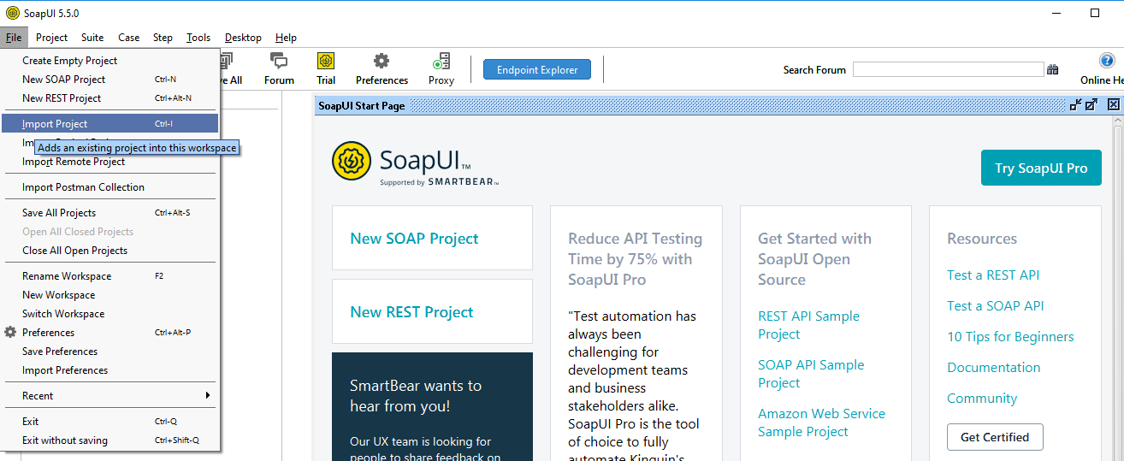

1. Import property file to load all properties to Kaching Project.

Select Project -> CustomProperties -> Loads property values from external file (**Kaching_property_file**)

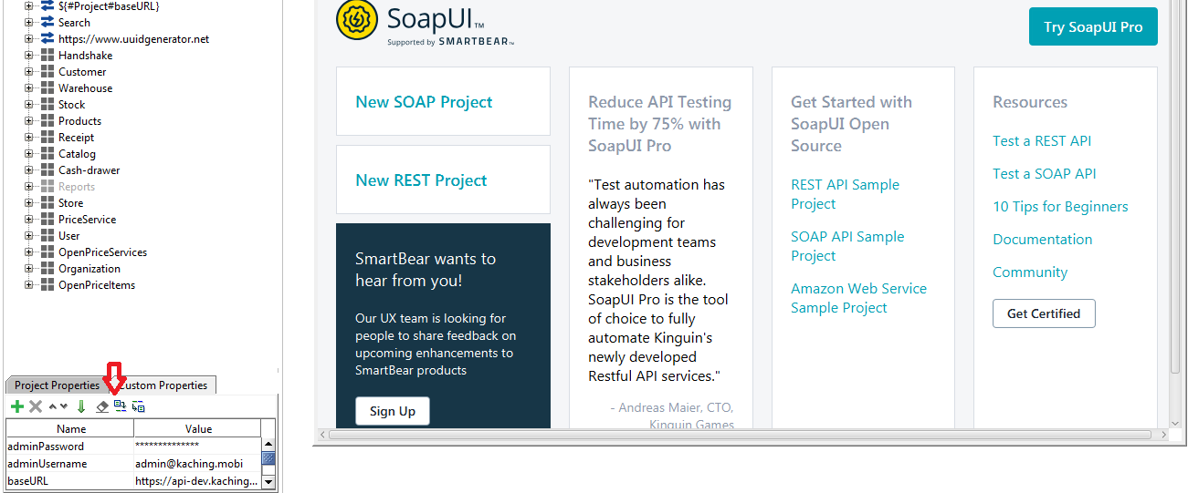

After import the project properties, user can change the property values as required. Eg- : Base url

**Use of environment -:**

Set up one environment Base url variable in project property level as it is common to all tests suites.

**Community edition all the tests suites and required endpoints are visible in same page in SOAP Project.**

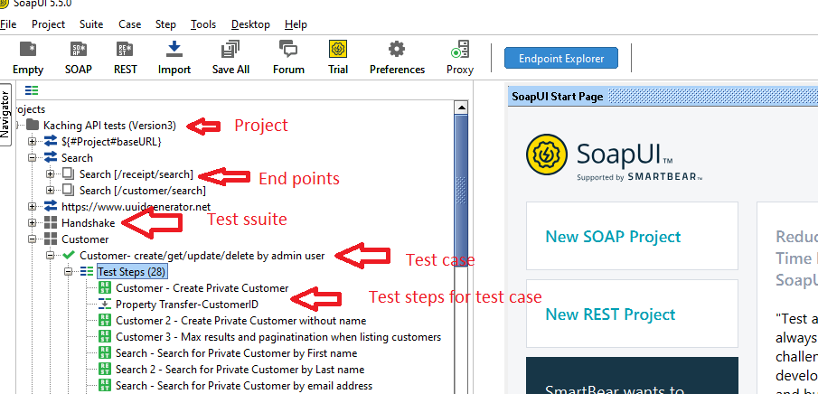

1. **How to add a new end point to soap project**

Able to add a new end point by right click on the endpoints list and select the add new recourse as following screen.

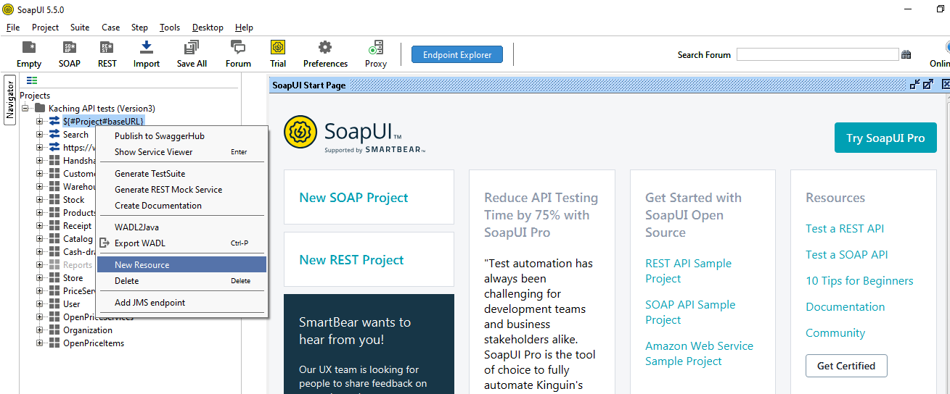

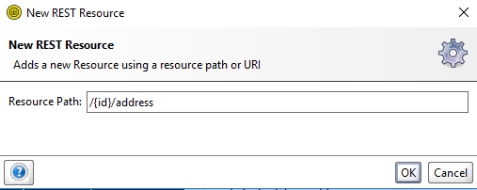

1. **How to create test suite to soap Project**

User is able to create new Test suite by right click on the project and selecting the New Test suite step

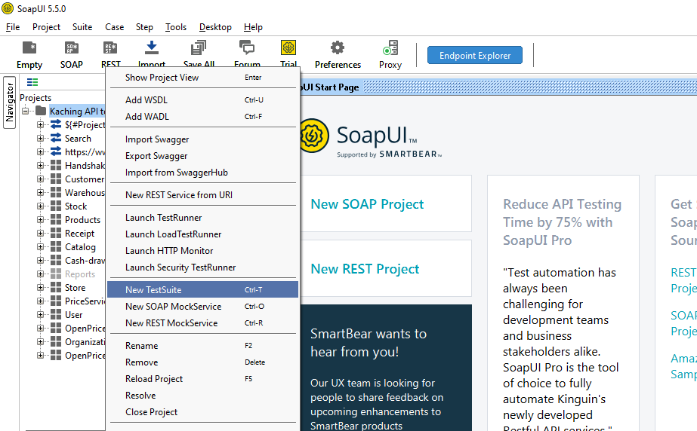

1. **How to add test case to test suite-:**

User is able to create new test case by right click on the test suite and selecting new Test Case step

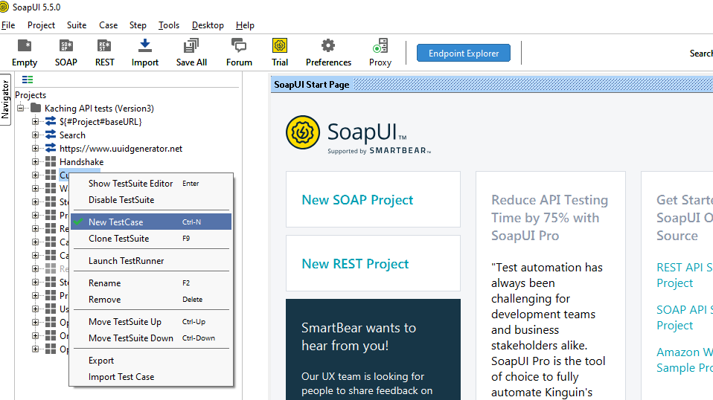

1. **Add test steps (Requests/endpoint) to test case. One test case can have multiple test steps**

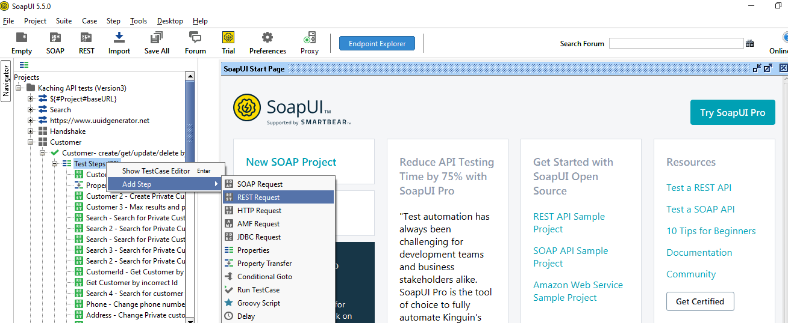

**8.Property Transfers**

Test cases (Scenarios) are created based on the functionality of end points. Positive and negative test scenarios can be created for each endpoint. To transfer the response values to other request user can use property transfer steps.

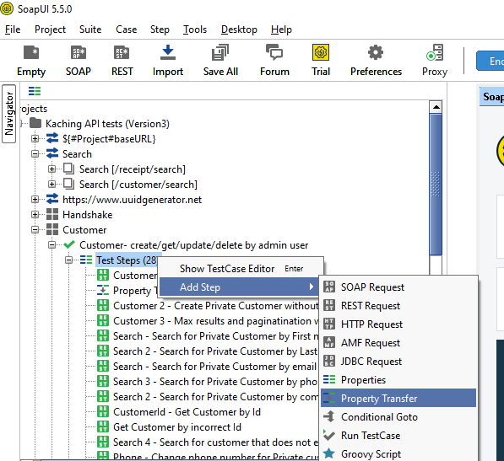

When transfer the property User should create a property variable which need to pass the property value of JsonPath. In community edition JSONPath should type manually as this $['customerId'].

Sometimes at the first time Setting the JSONPath as $['response']['customerId'] not working properly in community edition. So need to set up only as $['customerId'].

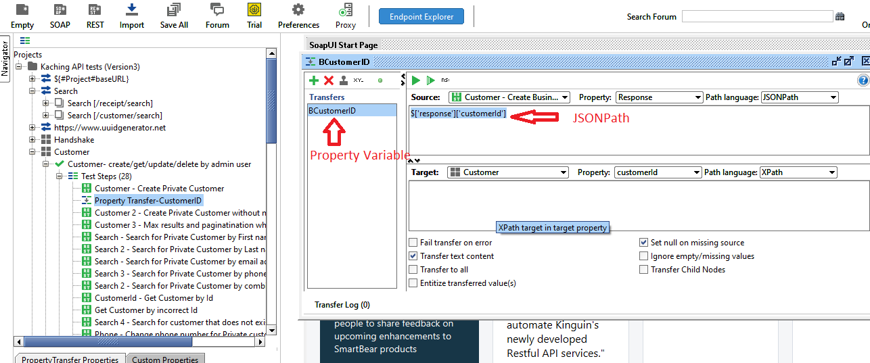

Test suites specific variables should include in test suite level properties. And tests case specific properties can be added in test case level properties.

1. **Creating Assertions**

* Select the tests Request
* Click on “**Assertion for the request**” tab
* Click on Add Assertion icon (**+**)
* User can add Assertions for status code and response values.

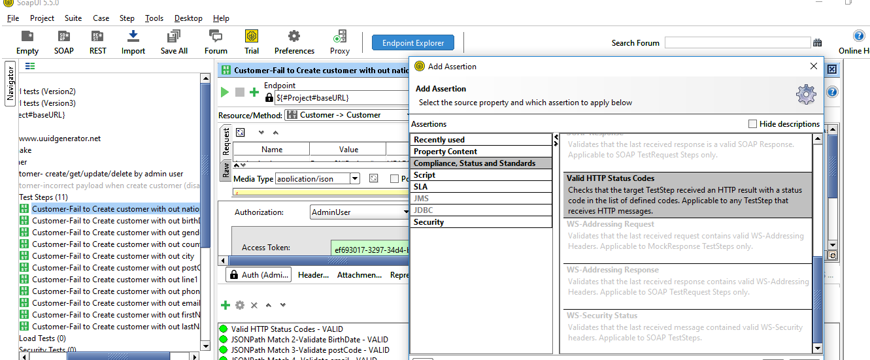

When creating assertions should remove “ “ from start and end of the sentence and also slashes / from Response values . Those signs support for Ready Api but not support doe Soap community edition.

1. **Set up Auth Token**

* Click on Auth tab
* Create Admin Profile and set up the wso2 environment token generation server details

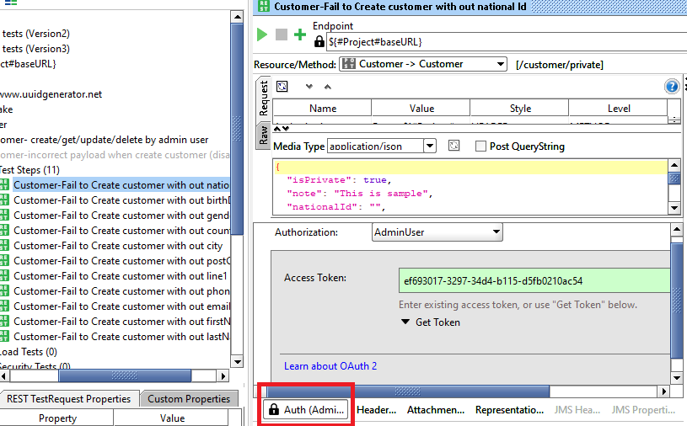

Set up wso2 server details as follows for Auth token

